JUnit Testing Exercises

Exercise 1: Setting Up JUnit
Scenario:
You need to set up JUnit in your Java project to start writing unit tests. Steps:
- Create a new Java project in your IDE (e.g., IntelliJ IDEA, Eclipse).
- Add JUnit dependency to your project. If you are using Maven, add the following to your pom.xml:

<dependency>
<groupId>junit</groupId>
<artifactId>junit</artifactId>
<version>4.13.2</version>
<scope>test</scope>
</dependency>

- Create a new test class in your project.

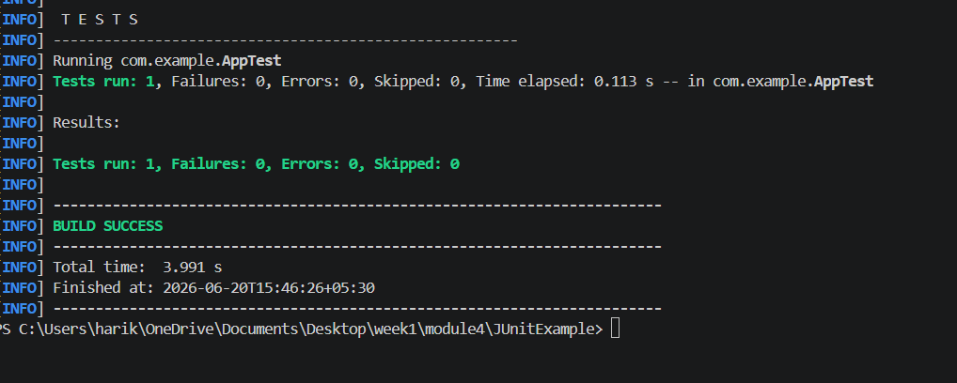

Exercise 2: Writing Basic JUnit Tests
Scenario:
You need to write basic JUnit tests for a simple Java class. Steps:
- Create a new Java class with some methods to test.
- Write JUnit tests for these methods.
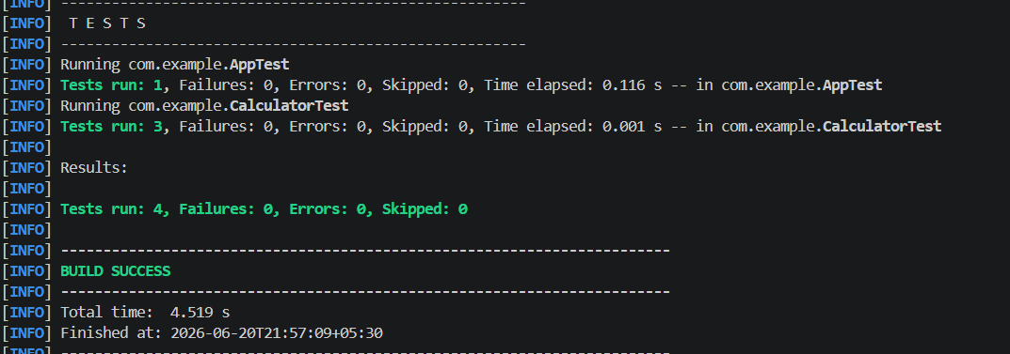

Exercise 3: Assertions in JUnit
Scenario:
- You need to use different assertions in JUnit to validate your test results.
Steps:
1. Write tests using various JUnit assertions.
Solution Code:

public class AssertionsTest { @Test
public void testAssertions() {
// Assert equals assertEquals(5, 2 + 3);

// Assert true assertTrue(5 > 3);

// Assert false assertFalse(5 < 3);

// Assert null assertNull(null);

// Assert not null assertNotNull(new Object());
}
}

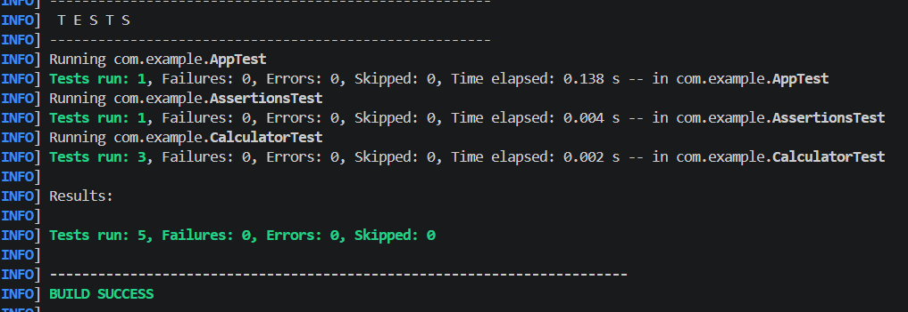

Exercise 4: Arrange-Act-Assert (AAA) Pattern, Test Fixtures, Setup and Teardown Methods in JUnit
Scenario:
You need to organize your tests using the Arrange-Act-Assert (AAA) pattern and use setup and teardown methods.
Steps:
- Write tests using the AAA pattern.
- Use @Before and @After annotations for setup and teardown methods. 